**Documentation and Description of Code**

The lab tasks consist upon comparing the complexities of matrix multiplication by using iterative method and Strassen’s Algorithm. The following is the brief description of lab tasks:

Task 01:

Task 1 performs matrix multiplication through iterative manner. The arrays of size 100 are initialized and are populated through ‘for’ loops using random numbers of range up-to 100. Both matrices are multiplied and the result is stored into third array using 3 nested for loops. This gives a code complexity of **n3**.

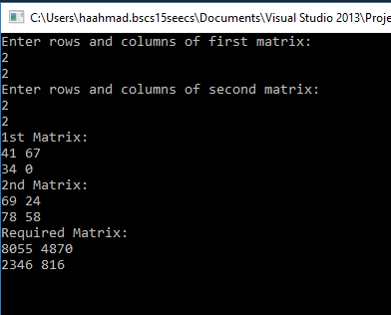

Task 02:

Task 2 is performed using Strassen’s Multiplication for 2x2 ordered matrices. The algorithm deploys divide and conquer approach where a larger matrix is divided into sub matrices. Here, the formula for implementation of Strassen’s algorithm for 2x2 is used in form of 2d-arrays and result is stored into 3rd array giving the complexity of **n2.807** .

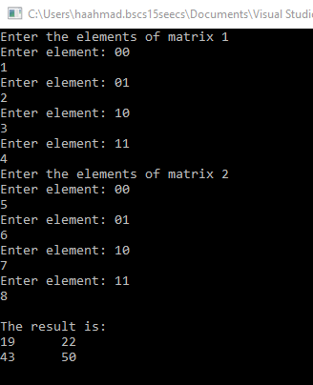

**The reason for this complexity**

The additions and subtractions in the code raise the complexity to n2 and it is done in 7 steps. The complexity becomes T(N)=7T(N/2) +) (N2). Using the Master’s method, the complexity becomes **n2.807**

NOTE: You can simply open the code files .